About this Paper

There can be nearly infinite considerations when deciding the best way to line an irrigation canal. This paper was created by a Geo-Form Lining client to guide them through their particular issues and to their ultimate lining selection.

Issue: The proper selection of a canal lining product for self-installation and maintenance.

The cost of canal liner maintenance is often unforeseen and not anticipated in the development of lining projects. The selection of a durable product which does not require an initial investment of contracted experts to oversee the installation and maintenance provides several advantages to include minimizing installation costs, the ability to quickly repair damage, the ability to expand the liner when conditions allow, and to minimize long-term maintenance cost to taxpayers. Additional costs to lining projects often include the unanticipated lead time on installation services due to contractor proximity to rural locations and the access to specialty material order back logs. Furthermore, program managers often overlook future maintenance costs once the project is complete. In a patron-based municipality, the ability to self-perform installation and maintenance on a quality product is key to keeping tax rates as low as possible.

Abstract

The selection of the proper canal liner for a project is not an easy process. There are several factors to consider including environmental conditions, product limitations, cost of installation, cost of maintenance, and the anticipated lifespan of the product. Many canal liners have installation limitations which vary from sub grade preparation, to vulcanization of liner segments, and ambient temperature restrictions. (Client) is exploring and identifying new technologies that circumvent the identified challenges in lessons learned from previous product installations.

Problem Statement
The Bureau of Reclamation has published several studies and reports on canal lining means and methods. Reclamation’s studies list three major materials used to line irrigation canals that were studied extensively. The results of those studies were most recently published in the Canal Lining Demonstration Project –Year 25 Durability Report (Sept. 2019). Those three materials are; concrete, concrete over a geomembrane, and exposed geomembrane. (Client) situated in (a region that) experiences below freezing temperatures from October through April. In addition, natural springs and water-table levels provide a constant flow of water in canals, even when the canals are not in use. Previous installations of concrete liners have proven to be a constant point of significant maintenance, a recurring budget item to repair or replace, and any expansion of concrete liners will exponentially increase future maintenance costs. The (canal section being studied for lining) currently requires roughly 300 linear feet of concrete removal and replacement each year. The failure mode of freeze thaw in a study performed by the Portland Cement Association states.
“When water freezes, it expands about 9 percent. As the water in moist concrete freezes, it produces pressure in the pores of the concrete. If the pressure developed exceeds the tensile strength of the concrete, the cavity will dilate and rupture. The accumulative effect of successive freeze-thaw cycles and disruption of paste and aggregate can eventually cause expansion and cracking, scaling, and crumbling of the concrete.” This leaves Reclamation’s recommendation of Geomembrane as the only feasible choice of liner for the (canal section to be lined). However, the amount of groundwater from the surrounding water table and natural springs in the canal inhibits the use of traditional installation methods.

Background of the (canal section to be lined) and why action is needed
The Bureau of Reclamation identified the (canal section to be lined) as a Category 2 maintenance item in a 2016 RO&M urbanized canal inspection. Reclamation’s inspection notes reads as follows on the report. “2016-2-D To mitigate seepage areas through embankment of the (canal section to be lined) located approximately 300 feet upstream of the (?)Canal. Placement of concrete lining in the canal prism approximately 200 feet in length. Lining should begin approximately 50 feet upstream of the most upstream seepage location.”
Based upon (Clients) previous experience with concrete lining we feel a geomembrane liner would be a more suited selection for this area due to the historic costs of continuous repairs and replacement of concrete liners in this region.
Unfortunately, the (canal section to be lined) also has the obstacle of natural occurring springs and is below the ground water table resulting in seepage into the canal during the non-irrigation portion of the year. This requires the addition of ballast rock to be applied over the top of any geomembrane liner. The use of ballast rock over the liner demands the performance of the selected liner to be suitable for the added stress load. Additionally, flexibility is desired for future maintenance and expansion of the liner as manpower and budget expenditure allows.
Background ----- Canal Lining Selection Process
(Client) and Reclamation want to insure that the proposed section of the (Canal section to be lined) does not experience a catastrophic failure. Lining also prevents water lose due to seepage. The logical solution in a heavy freeze zone where water is always present is to install an impervious lining.
The challenge of the lining material selection process for the (Client) is to identify the lining with the attributes that are best suited for (Client’s) work force capabilities, solves the problem for Reclamation, and yields the lowest annualized cost.
The use of concrete is given low consideration by the (Client) because previous experiences have proven that concrete linings have failed prematurely due to cracking and uplifting caused by ground water and the annual freeze/thaw cycle in the (area) basin.
Exposed geomembrane is difficult to evaluate. The complexity of the problem is best stated by the following excerpt from a paper, “Optimum Use of Geomembrane Materials in Irrigation Canal Lining”, written by Dr. Ian Peggs;
“All geomembrane materials, like HDPE, Linear low density polyethylene (LLDPE), Polyvinyl chloride (PVC), Flexible polypropylene (fPP), Chlorosulphonated polyethylene(CSPE), “Ethylene-propylene diene monomer (EPDM), bituminous geomembrane (BGM)), and Polyurea (PU), are effective in reducing water seepage/ leakage and allow increased flow rates. However, in practice, they may not be totally leak-tight. They differ in their abilities to lay and remain flat as temperatures change, in their abilities to conform to rough subgrades and differential settlement without impacting durability, in their tolerance of installation damage, UV radiation and oxidation, and in their abilities to be easily installed and repaired.”
There were two other paragraphs in Dr. Peggs’ paper that provided valuable guidance for selecting a lining for the Upper “C” proposed project. The first was:
“There are six basic considerations for the selection of a geomembrane material, viz, (1) New canal or lining of existing unlined canal, (2) Roughness of sub-grade, (3) Weather during installation, (4) Experience of installation personnel, (5) Covered or exposed installation, and (6) Cost of installation.”
And the other paragraph that was very appropriate for K.I.D.’s project explains the value of a lining’s property of “Ductility”.
“While reinforced geomembranes such as RPP, PVC alloys, and CSPE (Hypalon) have higher strengths, they have much lower elongations at break; therefore have less ability to conform to rough subgrades. Ductility in a geomembrane is often a far more important parameter than strength.”
The “25 Year Report” lists several geomembrane materials that were studied. Results of their service life was explained, years of service and cause of failure. The benefit/cost ratio varies from 2.2 to 3.8. It is understood that this study began 25 years ago, therefore, the costs of materials, labor and water have significantly increased, and new lining materials have been developed. The details of these B/C ratios could be challenged ad nauseam; however, the demonstration project was a tremendous undertaking and required a very large investment of both time and money. It remains the best information available for selecting the right canal lining for a given project and is considered “reasonably right”.
A list of lining properties and characteristics was compiled after (Client’s) review of the USBR’s multiple reports of the Canal Lining Demonstration Project, from Dr. Ian Peggs’ paper, “Optimum Use of Geomembrane Materials in Irrigation Canal Lining”, The Geosynthetic Institute’s various White Papers, and from consultations with geomembrane industry personnel.
Essential Properties & Characteristics of Exposed Geomembrane Lining
Site Preparation - Minimum subgrade preparation is important to save time and money. Shaping and berm trenches are expected, however, the requirement of trucked in soil and the cost of placement for the use of underlayment is unacceptable.
Lining Installation – Work may be interrupted by rain or snow which can add significant costs if non-resident specialist crews are required. (Client) employees must be able to perform the installation with minimum training using existing equipment at any temperature that is safe for workers. This includes (Client’s) workers performing splices to the lining material.
Splicing/Welding - Field splicing must be leak-proof when performed at any safe working temperature and secure (stronger than the lining itself). Some lining materials require time consuming pressure tests on the seams to assure leak proof splices. A lining that could be visually inspected by a trusted trained employee with only occasional destructive tests along the berm is highly valuable and cost effective.
Rugged - Research stated that many leaks were caused by damage during installation; therefore, the lining should be able to withstand normal foot traffic and light duty rubber-tired vehicles without damage to the geomembrane.
Ballast - Research was found that revealed adding ballast frequently caused punctures which could not be detected. Addition of ballast also allows silt build up and vegetation growth. It is important to have a lining that is heavy, specific gravity above 1.0, and does not require ballast. However, if ballast is required in areas of lining up-lift caused by high flow velocity or ground water, then the lining must be able to withstand the placement of ballast without concern of undetected lining damage.
Dimensional Stability - The lack of dimensional stability requires detailed installation instructions regarding tension and temperature during installation. It can be the cause of flex failures and cold shock splice failure. The ideal lining should have at least 5 years of verifiable performance in temperature extreme climates confirming that it remained dimensionally stable with no flexing or cold shock splice failures.
Ductility - The word ductility used as a property of a geomembrane lining was a new concept to (Client) management when it was explained in Dr. Peggs’ paper. During the study and findings of some of the failures reported in the USBR 25 year report, it was concluded that this feature would be extremely desirable for the soil and ground water conditions present in the (canal section to be lined).
Repairs - The lining material must be easily repaired or patched during its life. Lining damage can occur for many reasons; therefore, the lining must be easily repaired by (Client’s) employees to avoid possible catastrophic consequences.
Aging/Life Expectancy - The Geosynthetic Institute has published documented studies that prove some polymers can have a life expectancy of over 30 years in a dry and arid climate. See GRI White Paper #6 (see table 6 on page 22) (Client) believes that it is reasonable to expect at least 20 years and possibly over 30 years of service life.
Cost – Finally, The lining cost will be evaluated using the parameters of the original USBR report R-02-03, “CANAL-LINING DEMONSTRATION PROJECT YEAR 10 FINAL REPORT”, Benefit/Cost Analysis – Chapter 5 Page 203. The desired result is a B/C Ratio of 3.2 or better.

Solution
The (Client’s) lining selection team used the above list of criteria to filter out the numerous options available. A notable observation was laid on the table early in the process. If two of the above properties were not waived, then many lining products would be immediately eliminated. Those two are; heavy, with a specific gravity over 1.0, and the property of ductility.
Most thermoplastics have a specific gravity of less than 1.0, including high- and low-density polyethylene, polypropylene, polyvinyl chloride and polyuria. The specific gravity of chlorosulphonated polyethylene is approximately 1.12 and EPDM may be as high as 1.4. However, these are thermoset polymers and cannot be heat welded. Splices require vulcanization or a chemical adhesive splicing system. Success of adhesive bonding is dependent upon temperature, humidity, quality of sub straight preparation and experience of workers.
Ductility requires that a lining have the ability to stretch. It must also have poor elastic memory which allows it to conform to a new shape without the ability to return. Many lining products have been designed to be thinner and lighter to provide longer one-piece rolls that reduce the number of field splices. To accomplish this, the lining must be made stronger. Strength is added in numerous ways; by adding textile or poly reinforcement, by composite laminations, etc. Regardless, the result of adding strength reduces the linings ability to elongate. The Geosynthetic Institute has advised that the best measure of ductility is the multi-axial elongation test. If a product data sheet does not include the results of this test, that lining most likely does not have the property of ductility.
Coincidentally, (Client) recently installed a geomembrane lining in the (X) flume. It is now approaching the end of the second water season and has successfully sealed the leaks and extended the life of the flume. (Client) managers learned more about this product while considering its use for other canal lining projects.
The polymer is an “EPDM Rubber Alloy”. The lining material is relatively new, and the first installation was in 2010. Since that time it has been installed throughout the Pacific Northwest and Alberta Canada. It has been placed over bare earth subgrade and over cracked concrete. Applications include canals, flumes, an on farm reservoir and BLM heli-pond and a truck tanker fill pond. It is worth noting that the product is manufactured in the United States and was developed in Washington State.
The lining supplier provided the following statements and documentation comparing EPDM Rubber Alloy lining to the Essential Properties & Characteristics of Exposed Geomembrane Lining listed above.
Site Preparation - There are detailed construction specification available, however, in summary the canal preparation consists of shaping as best possible, removal of large rocks and providing anchor trenches alone the berms. Size of trench required varies with the lining width. (See figures 1, 2, 3 & 4)
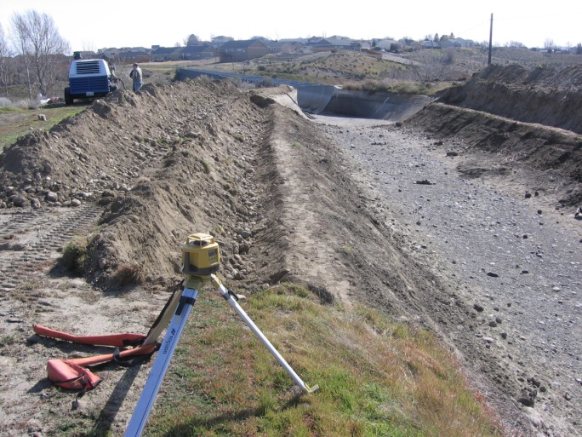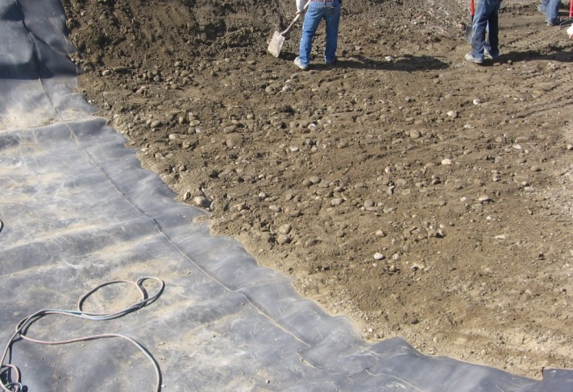
Figure 1 – Site preparation Figure 2 – Site preparation
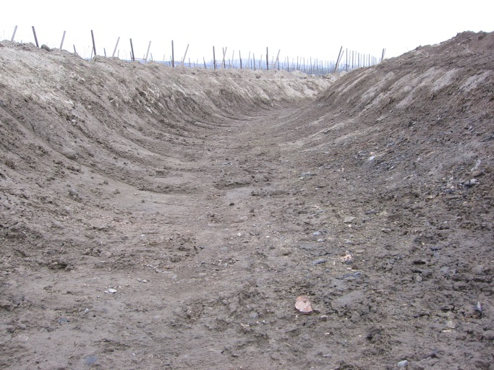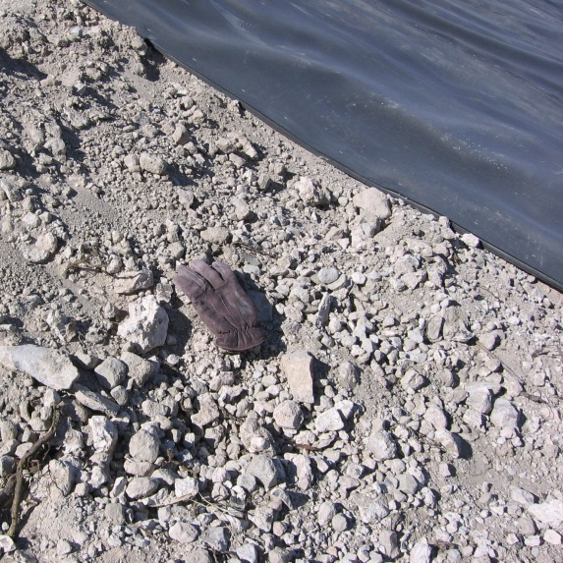
Figure 3 - Site Preparation Figure 4 - Site Preparation
Lining Installation – All EPDM Rubber Alloy lining has been installed by the employees of the owners or temporary day laborers. In two installations, prison work release laborers were used. The seam welders are fully automatic requiring only a brief training of clamping the welding tool into the seam and then tending the power cord to opposite side where it is removed. (See figure 5 & 6)
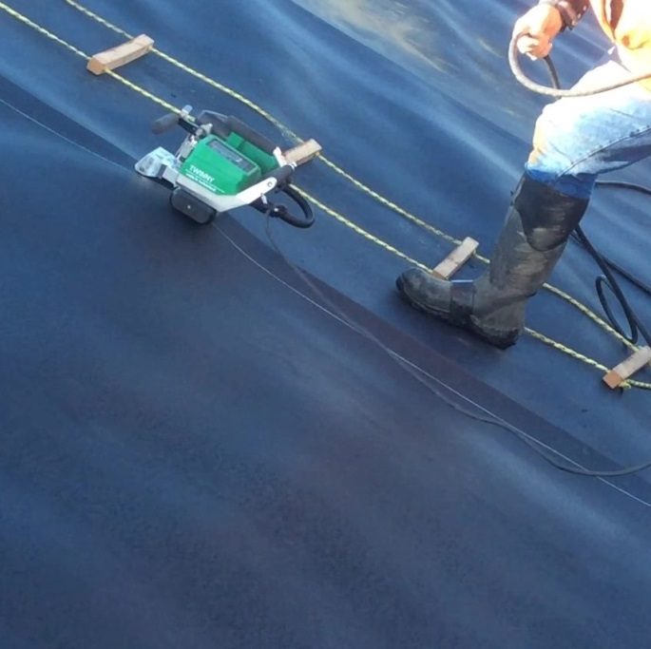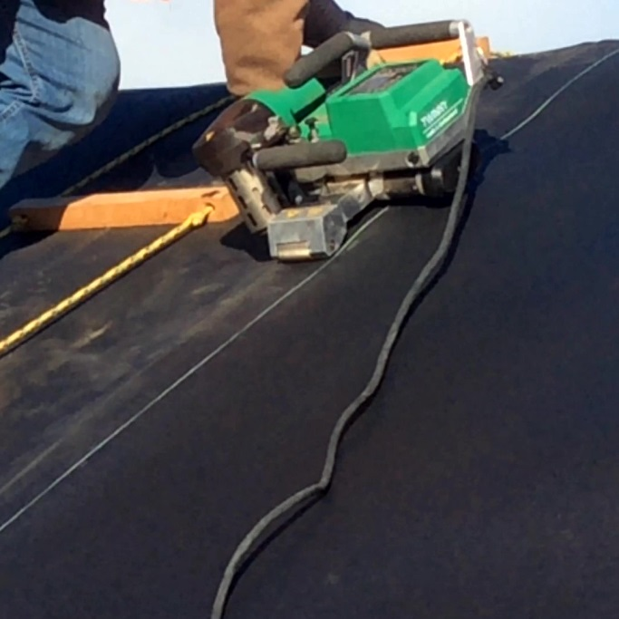
Figure 5 Lining installation Figure 6 Lining installation
Splicing/Welding – The EPDM Rubber Alloy formulation makes it possible to thermal weld a geomembrane sheet that is otherwise a thermoset polymer. Welding can be performed by either a hot air welder or a hot wedge welder. Both types weld at 10 ft./min. The welded width is 1 ¼” wedge and 1 ¾” hot air. The weld line is homogeneous, meaning the overlapping edges are melted together and no other material is introduced. The only preparation of the weld is to assure that the lining faces are not wet and free of contamination. The welding process can tolerate some dampness and dust. The lining has been successfully welded at 10 degrees F. Welds are at full strength as soon as cooled and are stronger than the lining itself. It is possible to make the double weld leaving the air pressure test chamber if that test method is required; however, it is not necessary as seams may be visually inspected by assuring that the flash bead is completely visible along the seam. (See figure 7, 8, 9 & 10)

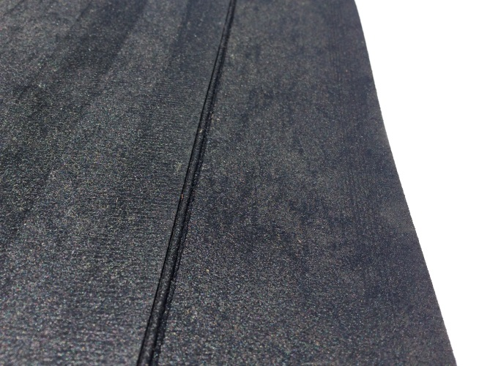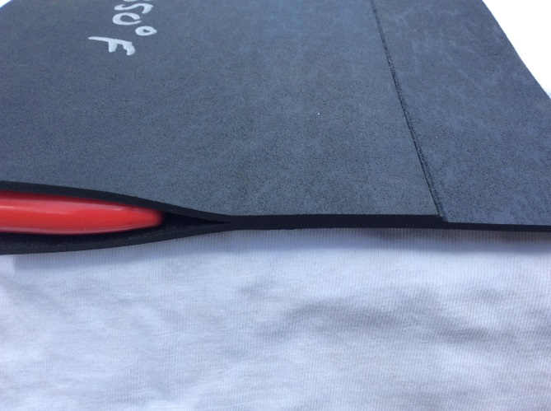
Figure – 7 Flash bead along weld Figure 8 – 1 ¼” wide overlap weld

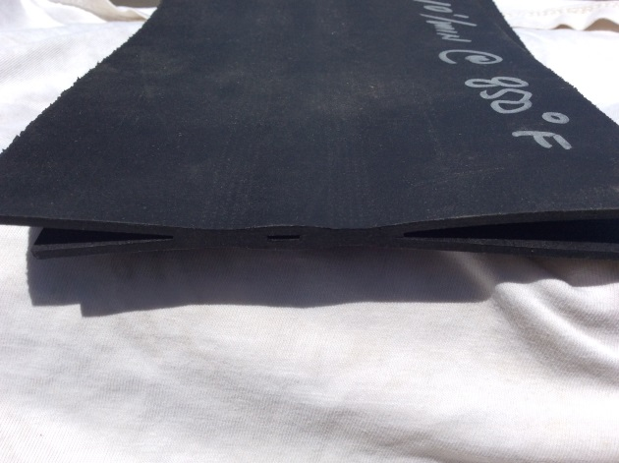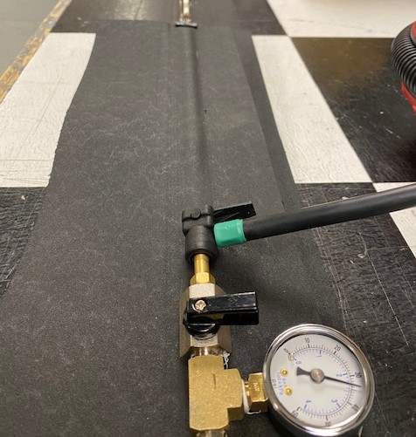
Figure 9 – Weld with test chamber Figure 10 – Pressure testing weld
Rugged – The EPDM Rubber Alloy is thicker than any other affordable exposed geomembrane available. At .100” thickness, it has the feel of rubber matting. One site where (Client) was considering using this lining was exposed to cattle. An unscientific test was conducted by placing the lining in a feed lot, part on concrete and part on bare dirt. The lining was in place for one week, then cleaned and inspected. The result was one puncture the size of a quarter. (See figure 11 & 12)
(See figure 13 & 14 for other examples of ruggedness)
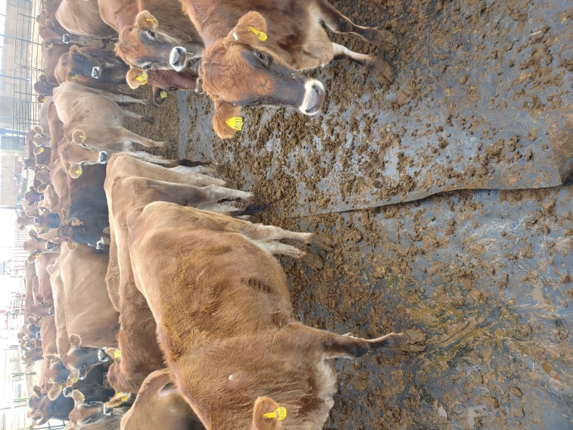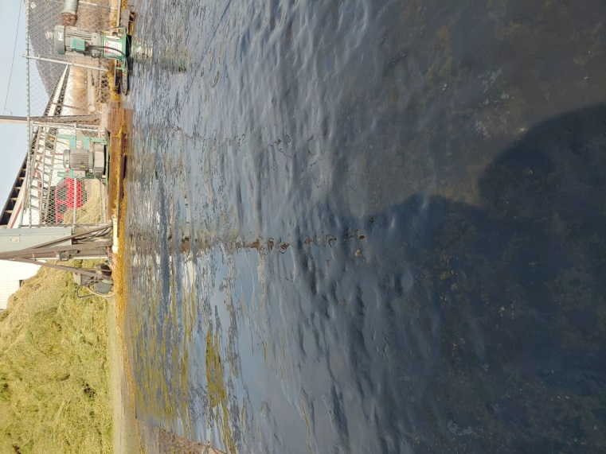
Figure 11 – Cattle feed lot Figure 12 – Lining after 1 week
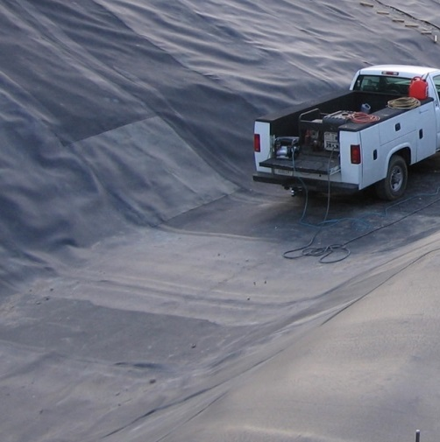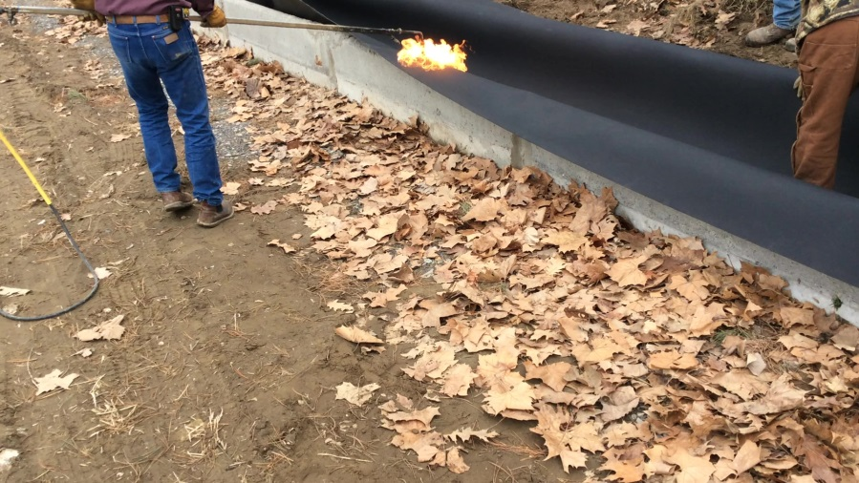
Figure 13- Pick up on lining Figure 14 – Lining flame formed to concrete flume
Ballast – The specific gravity of the EPDM Rubber Alloy is 1.19 and is .100” thick. The weight is .6 #/sq.’. At this weight, ballast is normally not required; however, the water velocity at check structures or drops may require rock ballasting. Also, uplifting from ground water may cause an undesirable condition where rock ballast may be needed. If ballast is required, this lining has proven to be able to sustain the dropping of ballast without damage. (See figure 15 & 16)
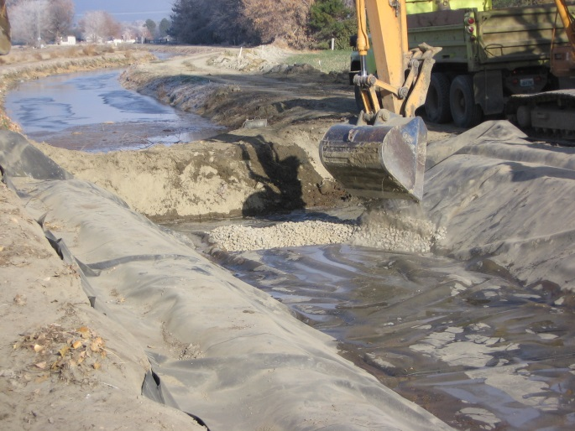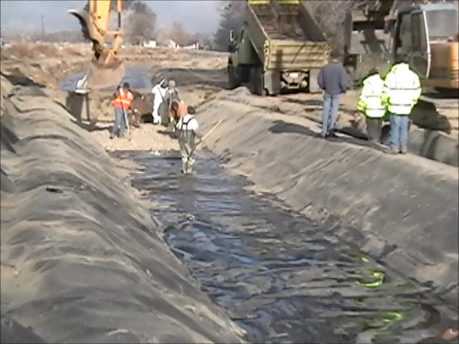
Figure 15 – dumping the rock Figure 16 – Spreading the ballast

Dimensional Stability – EPDM Rubber Alloy lining has been laid at temperatures as low as 10 degrees F and in lengths as long as 150 feet by simply pulling it flat. Because of the weight and thickness, there are no small wrinkles or folds. There have been no reports or observations of whales or hippos from uplifting or extreme temperatures. The lining will shrink and expand with temperature change when it is not secured; however, after it is secured in the anchor trenches, it does not have the strength to move. This property is difficult to show in photos. Akron Rubber Development Labs has done most of the testing of the physical properties on this material. One of the observations they made was when specimens of the material were loosely pinned to a sub-straight it did not move during elevated temperatures. The supplier has offered several references that have observed the material in their canals for confirmation of dimensional stability.
Ductility – In 2011 Dr. Robert Koener of the Geosythetic Institute advised that the best method to determine ductility was ASTM D 5617 Multi-axial Tensile test. He stated that the desired result for geomembrane lining used under landfills where it was intended to last in excess of 100 years would be 100% elongation. Upon that advice, EPDM Rubber Alloy was tested by TRI/Environmental, Inc. in February of 2011. The material tested was textured on one side and the thickness of .100” had an asperity height of .014” leaving a measurable thickness of .086. Today the lining is smooth on both sides and is a true .100” thick. It is believed that if the full .100” thick lining was tested; it would be at least 10% higher elongation at failure than the 52% average test results. It is noteworthy that the failure description of a hole was verbally described as a pinhole leak which terminated the test. (See figure 17 for example of EPDM Rubber Alloy molded to and irregular canal shape. Further, a back-side bank and a narrow front berm prevented the use of anchor trenches. Figure 18 shows how the lining stretched as an underground spring eroded the canal berm behind the lining. See figure 19 for actual test report)

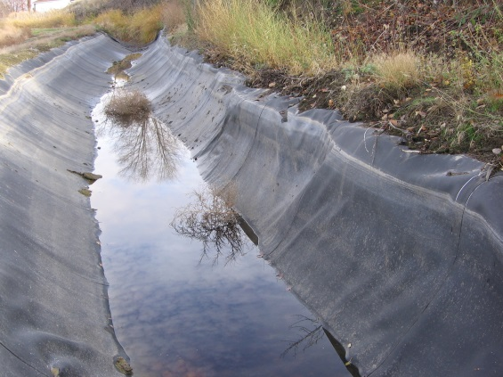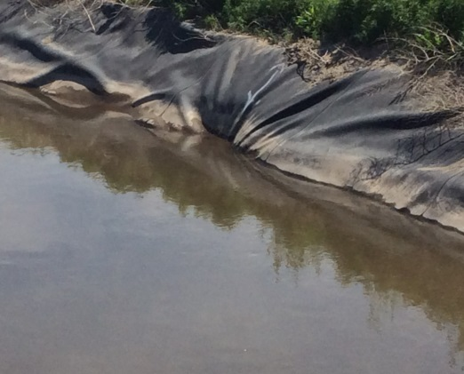
Figure 17 – Lining molded to canal Figure 18 – Lining stretched as soil eroded

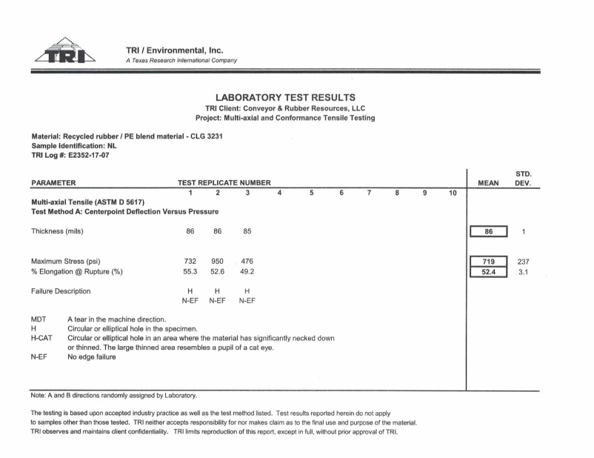
Repairs – EPDM Rubber Alloy can be easily repaired using commercially available handheld plastic welding tools. Simply cut a piece of lining in any shape required and weld the edges to the damaged lining. This technique can be taught to employees in minutes. Figures 20 & 21 show a small patch made during installation and another done years later. Figure 22 shows a repair that required a complete pond bottom replacement.

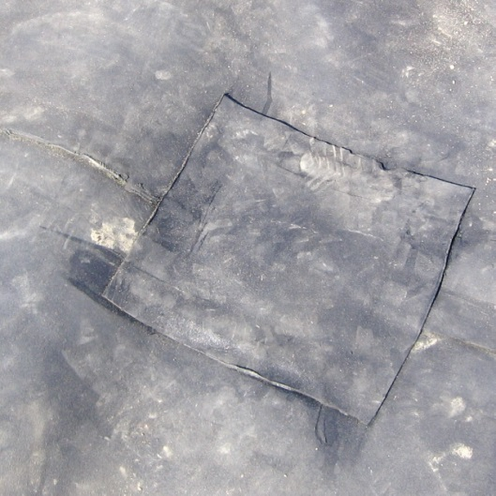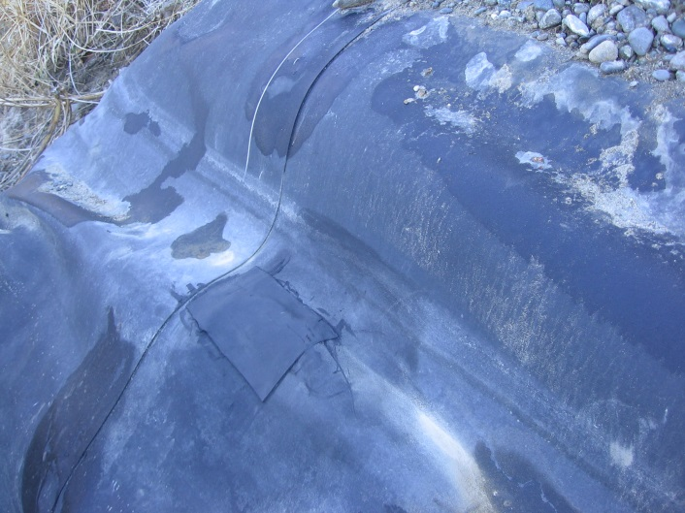
Figure 20 – Installation repair Figure 21 – Vandalism repair

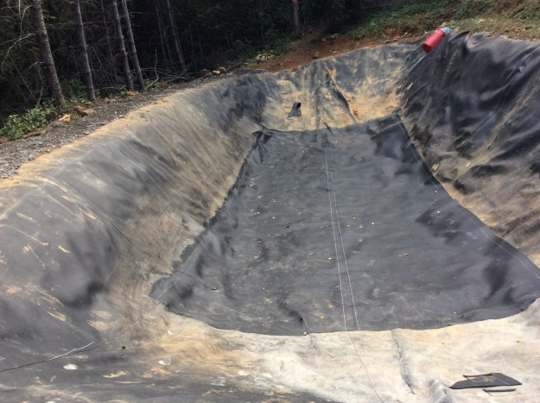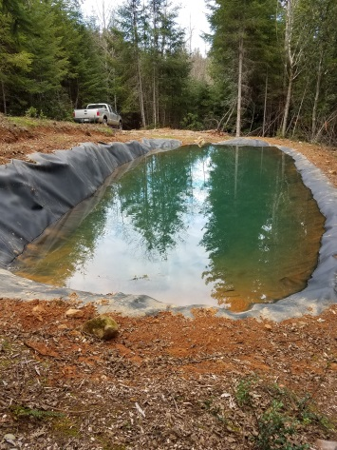
Figure 22 – Pond bottom lining replacement due to failure of original design.

Aging/Life Expectancy – This addresses the depletion of the physical properties of a geomembrane due to weathering; exposure to ozone and U/V, until the lining can no longer be trusted to remain leak proof. It should be noted that the EPDM linings studied in the USBR Demonstration Project were .045” EPDM sheets which required felt padding underlayment and gravel ballast. GRI White Paper #6 pg. 24 shows that EPDM has a lifetime prediction of greater than 27 years. Other thermoplastics in the EPDM Rubber Alloy formulation are over 30 years and all testing is ongoing. The EPDM Rubber Alloy sheet was tested to ASTM D 1149-07 and passed. A pass of this test would be expected to have a life expectancy of greater than 20 years in Arizona conditions. Lining that had been exposed for 10 years in Eastern Washington compared to unexposed fresh material was tested and there was no change in the durometer and only a 10% loss in tensile strength. It is known that material thickness also influences life expectancy. With this known information about the EPDM Rubber Alloy being considered, it can be expected to have a life of at least 20 years and possible up to 30 years.

